**VBA-challenge**

**Screenshots**

**Figure 1. Screenshot of 2016 stock data after VBA script was executed.**

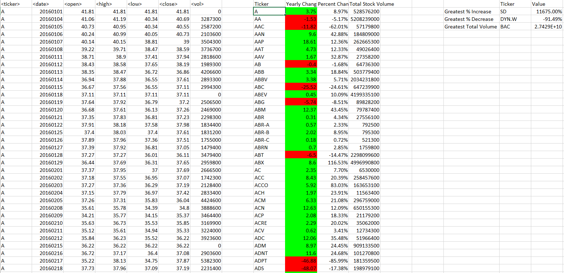

**Figure 2. Screenshot of 2015 stock data after VBA script was executed.**

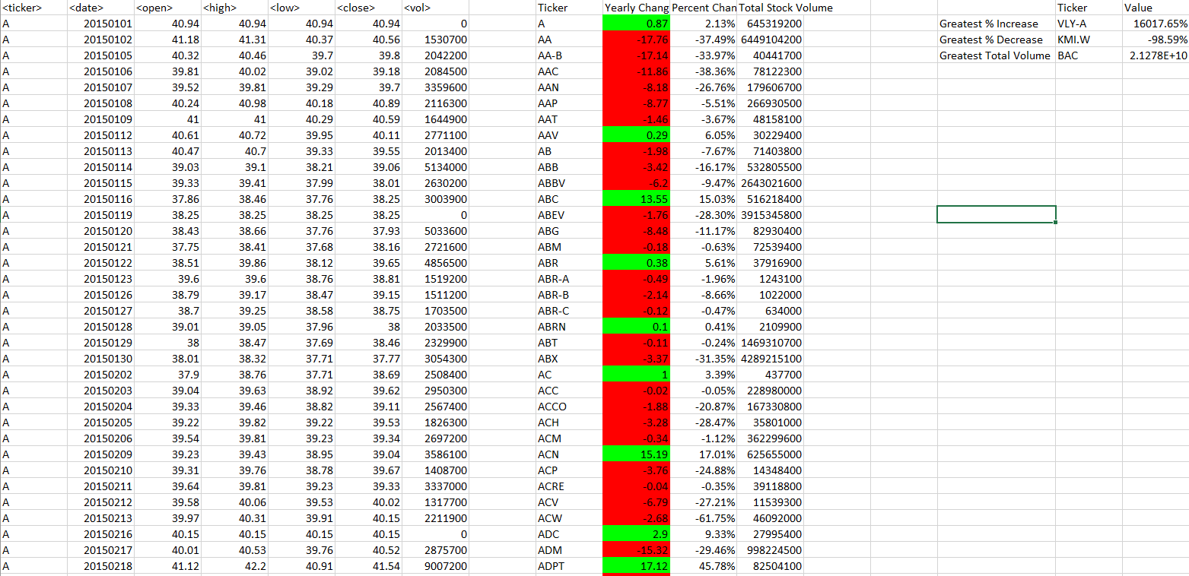

**Figure 3. Screenshot of 2014 stock data after VBA script was executed.**

